PETE LEVIN

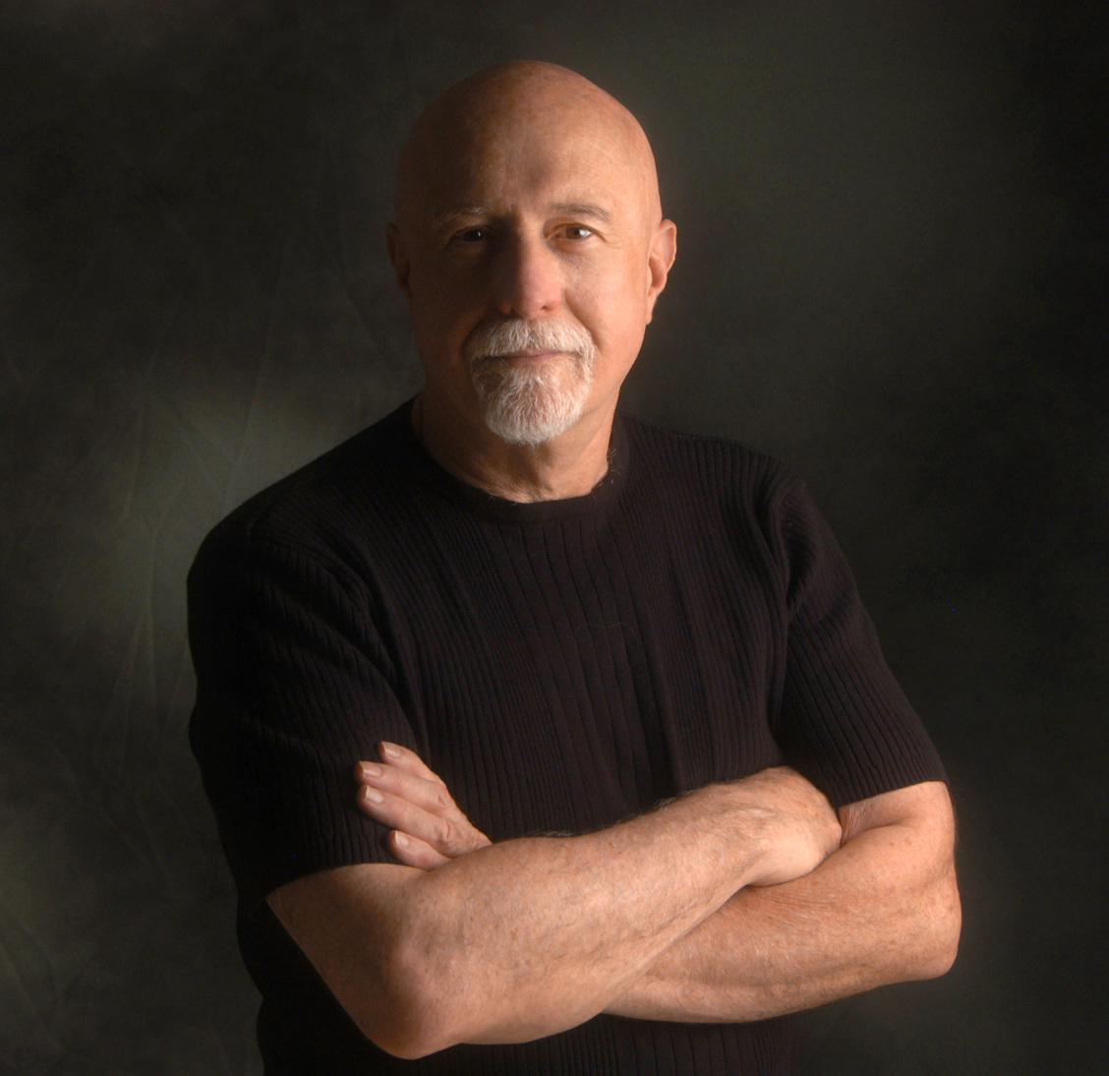
In a diverse music career spanning several decades, keyboardist/arranger Pete Levin has performed and recorded with hundreds of Jazz and Pop artists - including Paul Simon, Annie Lennox, Miles Davis, David Sanborn, Lenny White, Wayne Shorter, Jaco Pastorius, Robbie Robertson and John Scofield - receiving critical accolades for his work during a 15 year association with the legendary Gil Evans, and his 8 year stint with jazz icon Jimmy Giuffre. Says Levin,

“What I got from Gil was the unshakable notion that playing music was to create from a place where there are no boundaries. If it can be imagined then it can be done.”

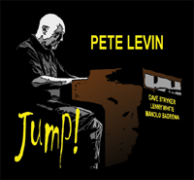
In 2010, Pete continues his organ trio CD series with JUMP!, this time featuring the remarkable Dave Stryker on guitar and legendary drummer Lenny White. They are joined on 5 tracks by percussionist Manolo Badrena. Pete and Dave began playing together relatively recently, but Pete and Lenny go back years to when they both were in Gil Evans' band. The final track on the album has a special background. Pete recorded Honeysuckle Rose with the late Joe Beck while planning an album project in 2008. It wasn't used on the CD. Recently Pete retrieved the track and finished it by having Danny Gottlieb overdub drums. They had worked together many times as a trio. It's straight ahead and "old school" but it's a sweet tip of the hat to Joe.

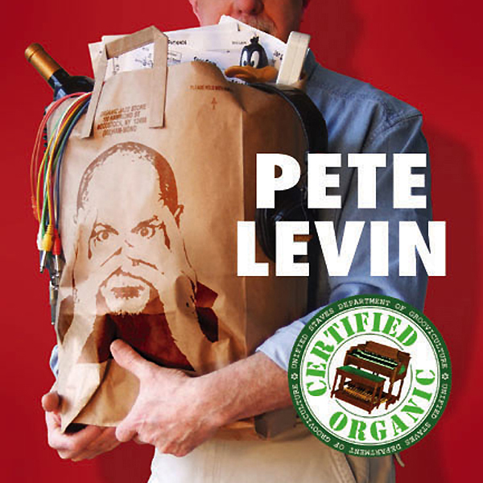
With “DEACON BLUES” for Motema Music, Pete re-emerged in 2007 as a band leader and master of reinvention, embracing his roots and first love, the Hammond Organ. Working with a group of iconic jazz sidemen (Joe Beck, Danny Gottlieb, Tony Levin, Mike DeMicco) Levin and company demonstrated an uncanny chemistry that was immediate and infectious. Pete followed up in 2008 with "CERTIFIED ORGANIC", continuing to push the envelope of the classic organ trio. In addition to his soaring Hammond, he demonstrates once more that he knows how to feature his sidemen, giving plenty of playing space to the 4 guitarists on the album - John Cariddi, Joe Beck, Mike DeMicco & Jesse Gress - as well as saxophonist Erik Lawrence and drummer Harvey Sorgen.

While playing French Horn with the Gil Evans Orchestra in the early 70s, Levin brought a Moog Synthesizer to a gig at New York’s Village Vanguard. Already known as a “go to” synthesizer specialist, Pete was at the vanguard of that technology. Gil loved it and Levin’s role was permanently changed as the band transformed itself into the electric/acoustic hybrid ensemble that captivated audiences worldwide for years, winning two Grammy® awards along the way.
“I started bringing a Clavinet, too. Eventually Gil brought John Clark into the band because I couldn’t get back to my horn in time. After a while, I just stopped bringing it. Name another band leader that would let a sideman do that! I owe him a lot.”

An in-demand New York session keyboardist for over 30 years, Levin has also created electronic realizations for hundreds of TV commercials, dramatic series and feature films, including “Missing in Action,” “Lean on Me,” “Silver Bullet,” “Red Scorpion,” “The Color of Money,” “Maniac,” “Spin City,” “America’s Most Wanted” and “Star Trek.” In a dizzying array of unrelated commissions, Levin composed orchestral scores for the feature film “Zelimo” and for a stage production of “The Dybbuk;” had the honor of composing the anthem for the 1992 United Nations Earth summit, “The Future is in Our Hands,” performing it twice for the U.N. General Assembly; and, as far removed from Jazz as it gets, was awarded the Army Commendation Medal for writing the official military band arrangement of the U.S. Infantry song.

But Levin, whose wry sense of humor is never far from the surface, reveals that his all time favorite recording session produced the top-40 hit single “Close to You” by The Clams, a Spike Jones tribute band formed with his brother, bassist Tony Levin (Peter Gabriel, King Crimson), drummer Steve Gadd (Eric Clapton, Paul Simon) and Grammy® winning recording engineer Dixon Van Winkle (Paul McCartney, Frank Sinatra). Thirty years later the recording is still a cult classic.
“All my arranging and orchestrating work is grounded in what I experience in live performance, interacting with other musicians and audiences. That’s what I was trained to do. Synthesizers and computer programming came later. My best and most creative ideas come from playing live.”

In 1990, Levin signed with Gramavision to release his first solo jazz album, “Party in the Basement,” followed by “A Solitary Man” in 1991. Collaborating with drummer Danny Gottlieb, Pete released “The New Age of Christmas” on Atlantic and “Masters in this Hall” for Gramavision. In the years following, he released four New Age CDs for Alternate Mode Productions, and a variety of eclectic albums for independent labels.

With “Deacon Blues,” Pete returned to the cutting edge as a band leader, while tipping his hat to his mainstream jazz roots. Expanding on the traditional organ trio format, his innovative arrangements are flavored with soul, samba and hip-hop grooves. The set mixes four Levin originals with his unique treatments of familiar classics, including Steely Dan’s “Deacon Blues,” Ralph Towner’s “Icarus,” the Beach Boys’ “Sail on Sailor” and Erik Satie’s “First Gymnopedie.” The album features outstanding performances by bassist Tony Levin, guitarist Mike DeMicco, percussionists Ken Lovelett and Carlos Valdez, legendary jazz guitarist Joe Beck, and drummer, Danny Gottlieb. For Levin, this recording was a labor of love.

“The Hammond Organ has got such a rich history. There’s really no other sound quite like it. Even the best synth simulations fall short. You crank up the motor, you hit a note and it sings to you. It’s like the soul of every organ player is being breathed out from the instrument.”

Veteran career side men and solo recording artists, both Levin brothers produce their own albums close to home, collaborating with other world-class musicians in their Woodstock, New York community. Pete’s Hammond is featured on Tony’s latest critically acclaimed Narada release, “Resonator,” while Tony’s basses grace several tracks on Pete’s “Deacon Blues.”

“It’s predictable that most of my oldest and best friends are musicians. But, it’s amazing how many of them have had an impact on the way their instruments are played, and are respected by fans and peers all over the world. And I've got all their phone numbers and you can't have them. Eat your heart out!”

Michael Bloom Media Relations
P.O. Box 41380 Los Angeles, CA 90041
contact: Michael Bloom
tel: 323.258.6342 email: musicpr@earthlink.com

