pete levin trio

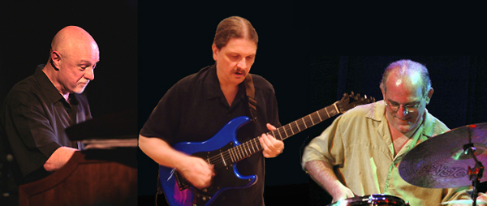
pete levin, organ john cariddi, guitar harvey sorgen, drums
info and electronic press kit at www.petelevin.com
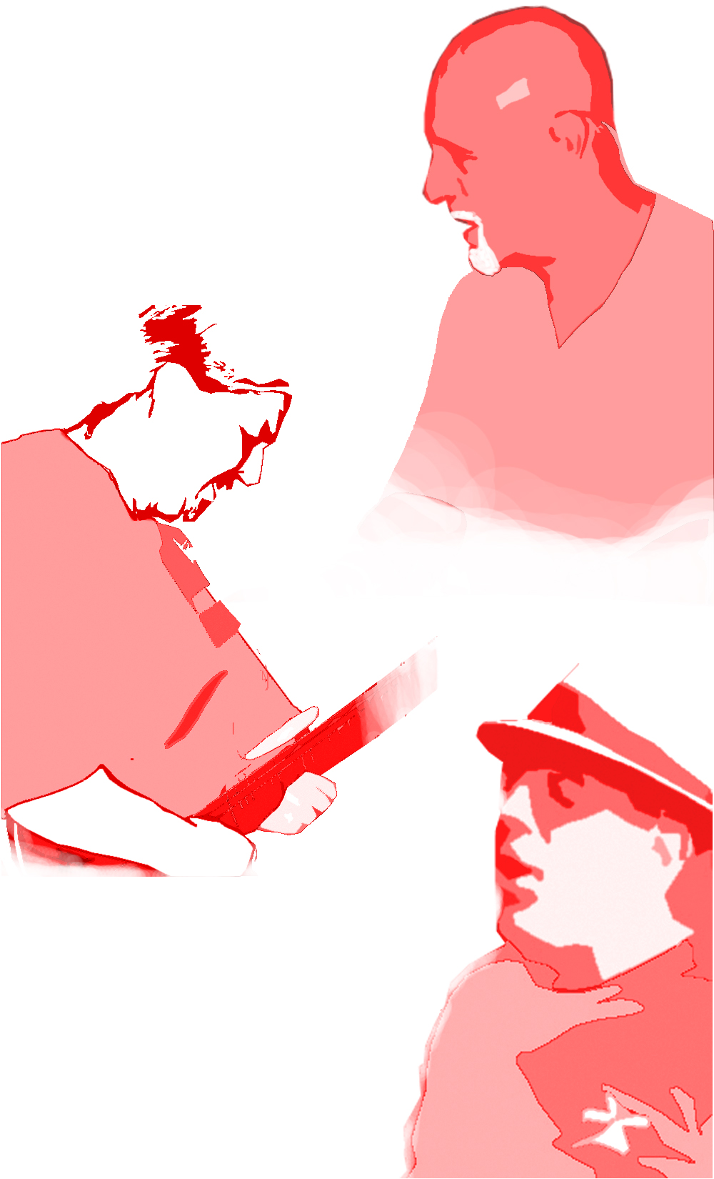
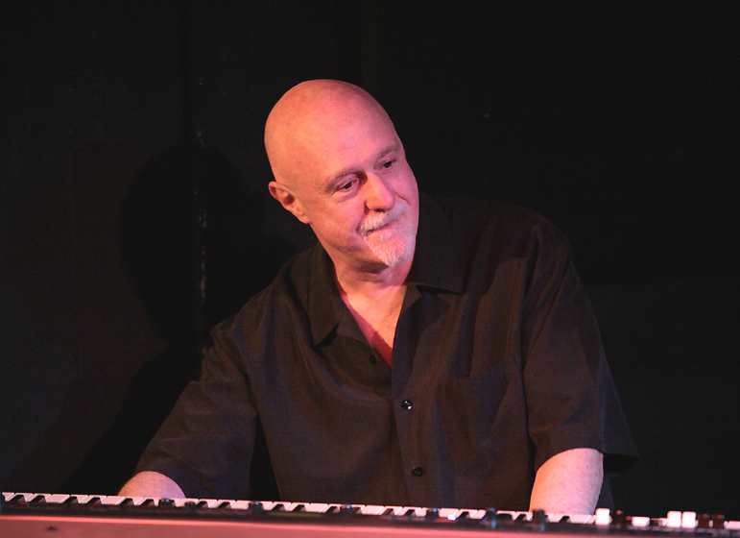
In a diverse music career spanning several decades, keyboardist Pete Levin has performed and recorded with hundreds of Jazz and Pop artists - including Paul Simon, Annie Lennox, Miles Davis, David Sanborn, Lenny White, Jaco Pastorius and John Scofield - receiving critical accolades for his work during a 15 year association with Gil Evans, and his 8 years with jazz icon Jimmy Giuffre. In 1990 he released his first solo album, “Party in the Basement,” for Gramavision, followed by “A Solitary Man” and “Masters In This Hall.” In 2007, after a series of CDs for Alternate Mode, Pete returned as a band leader with the Motema Music release, “Deacon Blues,” while also returning to his first love, the Hammond Organ.


Composer and ubiquitous guitarist on the New York recording studio scene, John Cariddi has performed and/or recorded with Jazz and Pop artists including Steve Marcus, Patti Austin, Ricki Lee Jones, Angela DeNiro, Annie Haslam, Nancy Wilson, and Peggy Lee. A master guitarist with a blazing technique, John's dynamic approach to live performance has made him one of the most in-demand guitarists in the New York area.
"The New York artist has a serious keyboard resume, so you'd expect him to lay down some real grease and gravy."
~ Downbeat, May '07

Levin and his cohorts not only don’t stop to take prisoners, they run roughshod over the terrain!
~ Jazz Review April '07

"A true master musician, Levin is never shackled by genre or form."
~ Freeman March '07

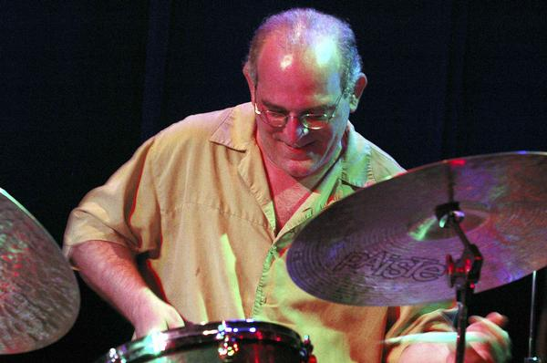
One of the most exciting drummers on the Jazz scene, Harvey Sorgen has performed and /or recorded with artists & bands including Hot Tuna, The Memphis Pilgrims, The Fonda/Stevens Group, Ahmad Jamal, Michelle Shocked, Paul Simon, Dewey Redman, Anthony Braxton, Carter Jefferson, David Torn, Roswell Rudd, Bill Frisell, NRBQ, Jimmy Vivino, Dave Samuels, and the Sorgen-Rust-Windbiel Trio. He has been featured in interviews in Modern Drummer, DRUM!, Down Beat, All About Jazz, Jazz Podium (Germany), and Jazz Halo (Belgium) magazines.

